Brain-Boosting Energy Balls
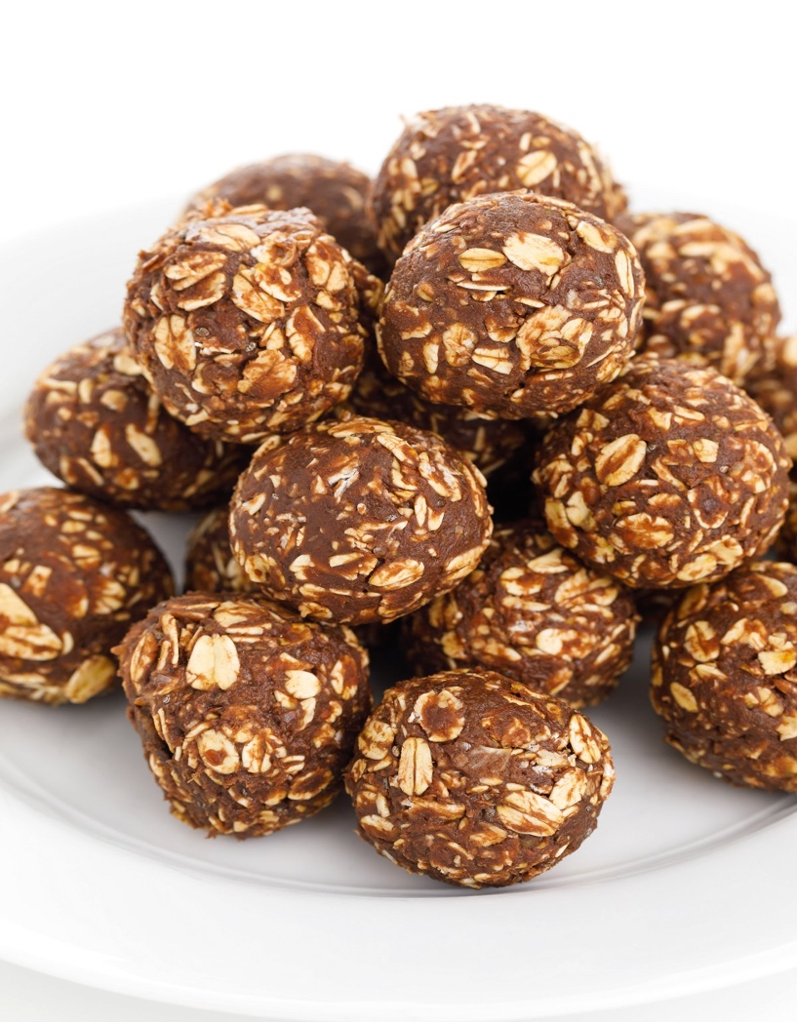
Makes about 1 dozen / Prep Time: 20 minutes
Dairy-Free, Egg-Free, Gluten-Free, Vegetarian
These are a staple in our house for a quick on-the-go snack. So many manufactured “bar” products are full of sugars and other fillers which can disrupt gut and brain health. These are simple to make, naturally sweetened, and can be amended to fit your preferences. Simply swap out the type of seed or nut butter if desired.
1-2 very ripe bananas, mashed
1 cup unsweetened almond butter (or peanut butter)
1 cup dry rolled oats (or quick oats)
1/4 cup unsweetened cocoa powder
1/4 cup unsweetened coconut flakes
1/4 cup chia seeds
1/4-1/3 mini chocolate chips
1. In a large bowl, combine the mashed banana, almond (or other nut) butter, cocoa powder, coconut flakes, and chocolate chips.
2. Using a spatula, mix everything together and using your hands, shape the mixture into 12 (1-inch) balls. Place them in a single layer on a baking sheet or large container. Cover and refrigerate at least 1 hour before serving.
3. Store the balls in an airtight container in the refrigerator up to 1 week or freezer up to 3 months.
Ingredient Tip: Natural nut butters, such as almond, do not contain processed oils like palm oil. The natural almond oil will rise to the top. Be sure to stir the almond butter very well before using to prevent these from being too runny. For best results, use almond butter that has been refrigerated for at least 12 hours and use when cold.

