Omega-3 Grain-Free Power Bowl
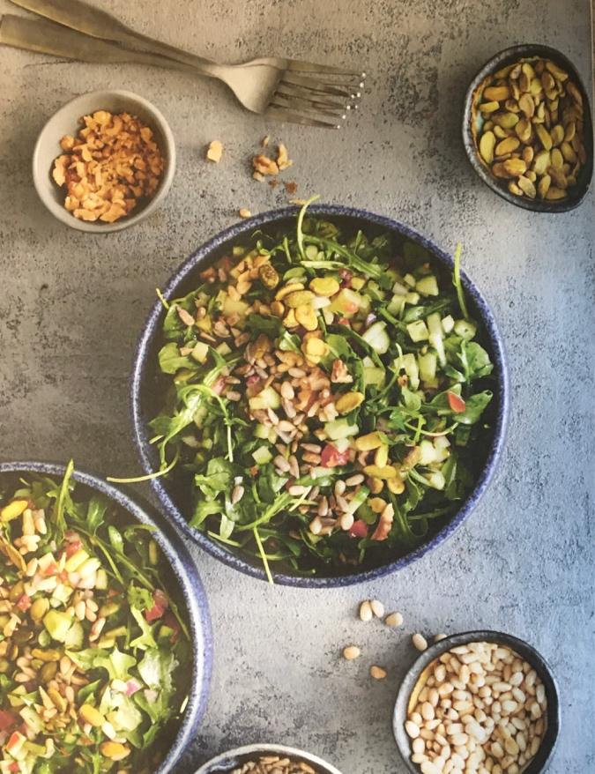
This beautifully simple version of the popular grain bowl is hearty enough to be a meal in itself with protein and healthy fats from a variety of nuts and seeds which also give it great texture and crunch. Use heirloom tomatoes in a variety of colors for an even more impressive presentation. Feel free to use baby spinach or your favorite baby lettuce in place of the arugula, if you desire.
Dairy-Free, Egg-Free, Gluten-Free, Vegetarian
Serves 4
Prep Time: 15 minutes
¼ cup pine nuts or slivered almonds
¼ cup shelled pistachios
¼ cup coarsely chopped walnuts
¼ cup shelled pumpkin seeds
¼ cup shelled sunflower seeds
2 large English (seedless) cucumbers, unpeeled and finely chopped
1 pint cherry tomatoes, finely chopped
½ small red onion, finely chopped
½ cup finely chopped fresh flat-leaf Italian parsley
2 tablespoons extra-virgin olive oil
2 to 3 tablespoons freshly squeezed lemon juice (from 1 lemon)
1 teaspoon salt
¼ teaspoon freshly ground black pepper
4 cups baby arugula
1. In a large dry skillet, toast the pine nuts (or slivered almonds), pistachios, walnuts, pumpkin seeds, and sunflower seeds over medium-low heat until golden and fragrant, 5 to 6 minutes, being careful not to burn. Remove from heat and set aside.
2. In a large bowl, combine the cucumber, tomatoes, red onion, and parsley.
3. In a small bowl, whisk together olive oil, lemon juice, salt, and pepper. Pour over chopped vegetables and toss to coat.
4. Add the toasted nuts and seeds and arugula and toss with salad to blend well. Serve at room temperature or chilled.
Leftovers Tip: If you decide to make a big batch of this at the beginning of the week, wait to add the arugula, nuts, and seeds until just before serving so they don’t get soggy in the dressing. This makes a great vegetarian light meal, but you can add a fried egg or leftover fish or chicken to make a heartier dish.

